module enchant is part of package pyenchant

BUT THERE IS ONE BIG PROBLEM.

For some reason, neither conda nor pip will help install the package pyenchant.

Also there is no support for this package. Having researched all the forums, there was one link that helped.

<https://www.reddit.com/r/learnpython/comments/3oju56/i_am_new_to_python_and_it_will_show/>

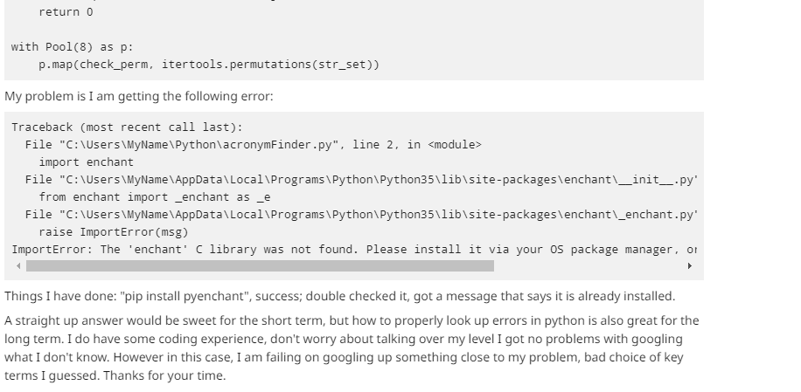

So installing the package is done as follows

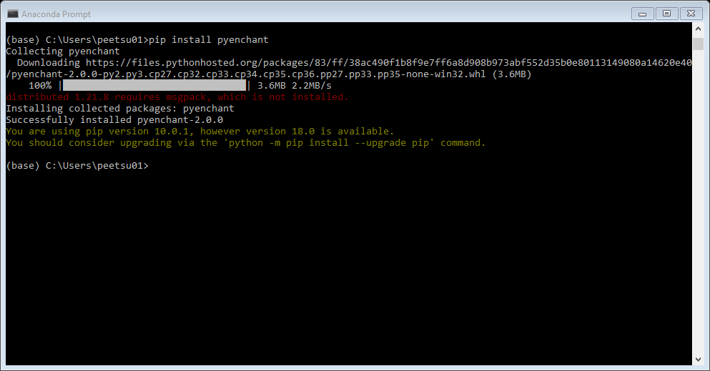

How to test it ?

Execute the following code and you should see the contents of the url in the output console

